# Name : Sathwik Hegde

**USN : 4MT19CS138**

# Network scanning

# 1. nmap 172.16.217.0/24

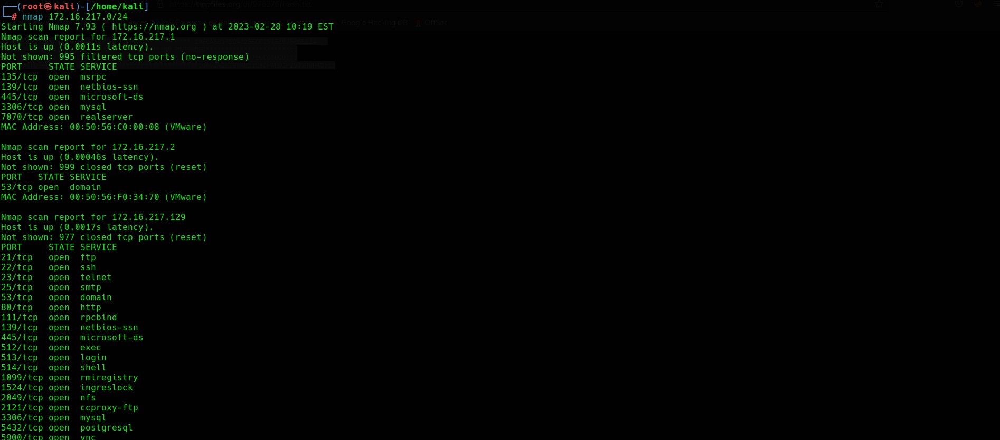

2. nmap -sU

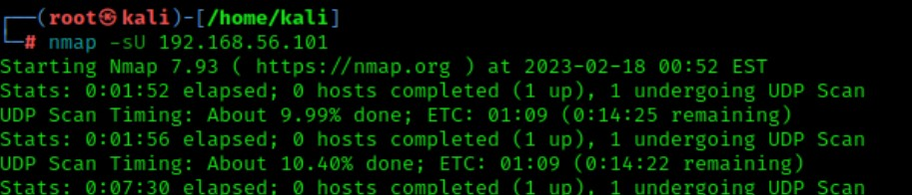

3.nmap -sT

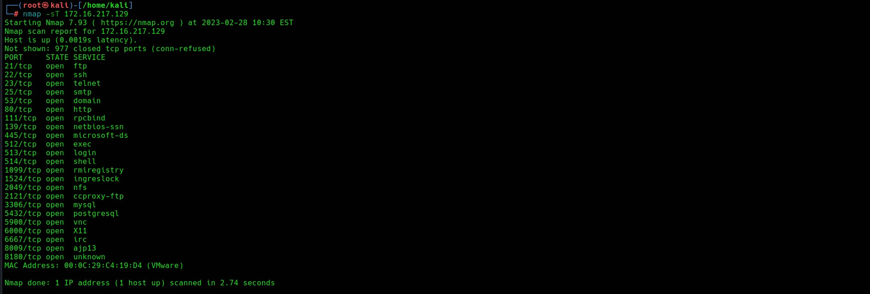

4.nmap -O

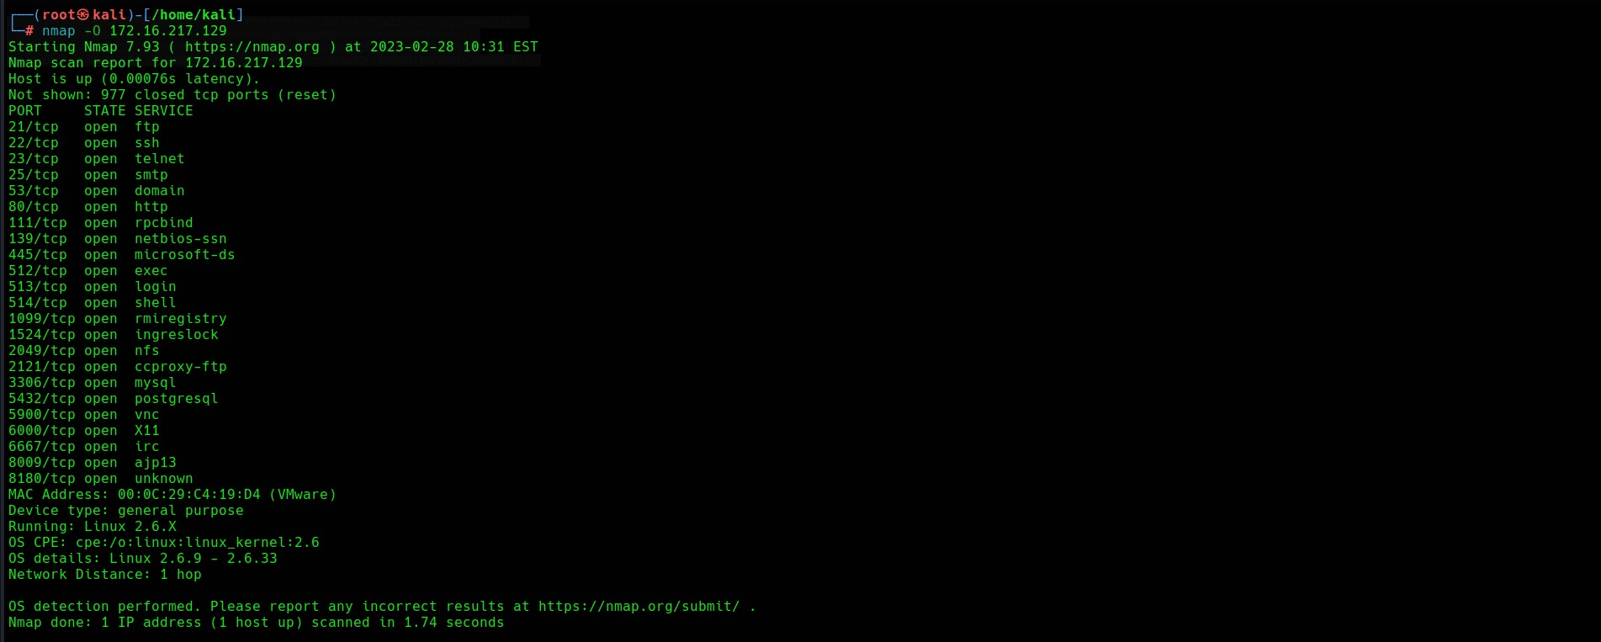

**5.nmap -p**

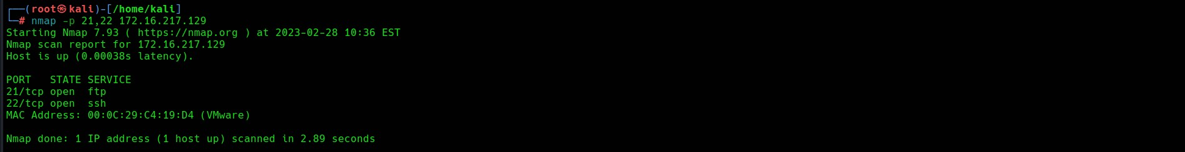

6.ping

